**Project 6 Coin Detection – Part 2 complete**

Name: Satvik Matta Period: 5 Date: 3/3/2023

Did you name your file l062.cpp (Lower case L, then 062)? Yes

Did you create the edge matrix? Yes

Did you create the gradient direction matrix? Yes

Did you create the imagev.ppm (visual of votes)? Yes

Did you use Bresenham's line algorithm for voting? Yes

Did you use the intersection with the border of the image or a similar approach when using Bresenham to vote? (fill in your answer)

I did use intersection with the border of the image or a similar approach when using Bresenham to vote.

Does your application create imageCircles.ppm file? Yes

Does your application create imageCoins.ppm file? Yes

Does your code processes all command line arguments specified in the course materials? Yes

Does your code display on the screen and in results.txt a summary of your results? Yes

Did you test your code on terminal/gnu linux in c++11? Yes

Run your code (the same code you submit) on the easy image I provided -then paste here the following:

* The initial image ( the one I provided), the imagev.ppm, imageCircles.ppm and imageCoins.ppm you obtained running your code, copy paste here the content of your results.txt file your code created

For the easy image:

Command line including all parameter values used for this image (including the ones you created with explanation of what is their meaning): (not a printscreen!)

./l062 -f image.ppm -lt 70 -ht 200 -ff imagef.ppm -TC 60 -fv imagev.ppm -fcc imageCC.ppm -TCircle 31 -fCi imageCircles.ppm -fCo imageCoins.ppm -fR results.txt -sQ 169 -sR 70

Everything except -sQ and -sR are the same as the instructions in the lab assignment on schoology.

-sQ is for the sobel thing for optimizing finding image Centers (I overheard from Raghav about this, I don’t know exactly what it is called) it determines the number of squares

-sR is the smallest radius in the image

Initial image:

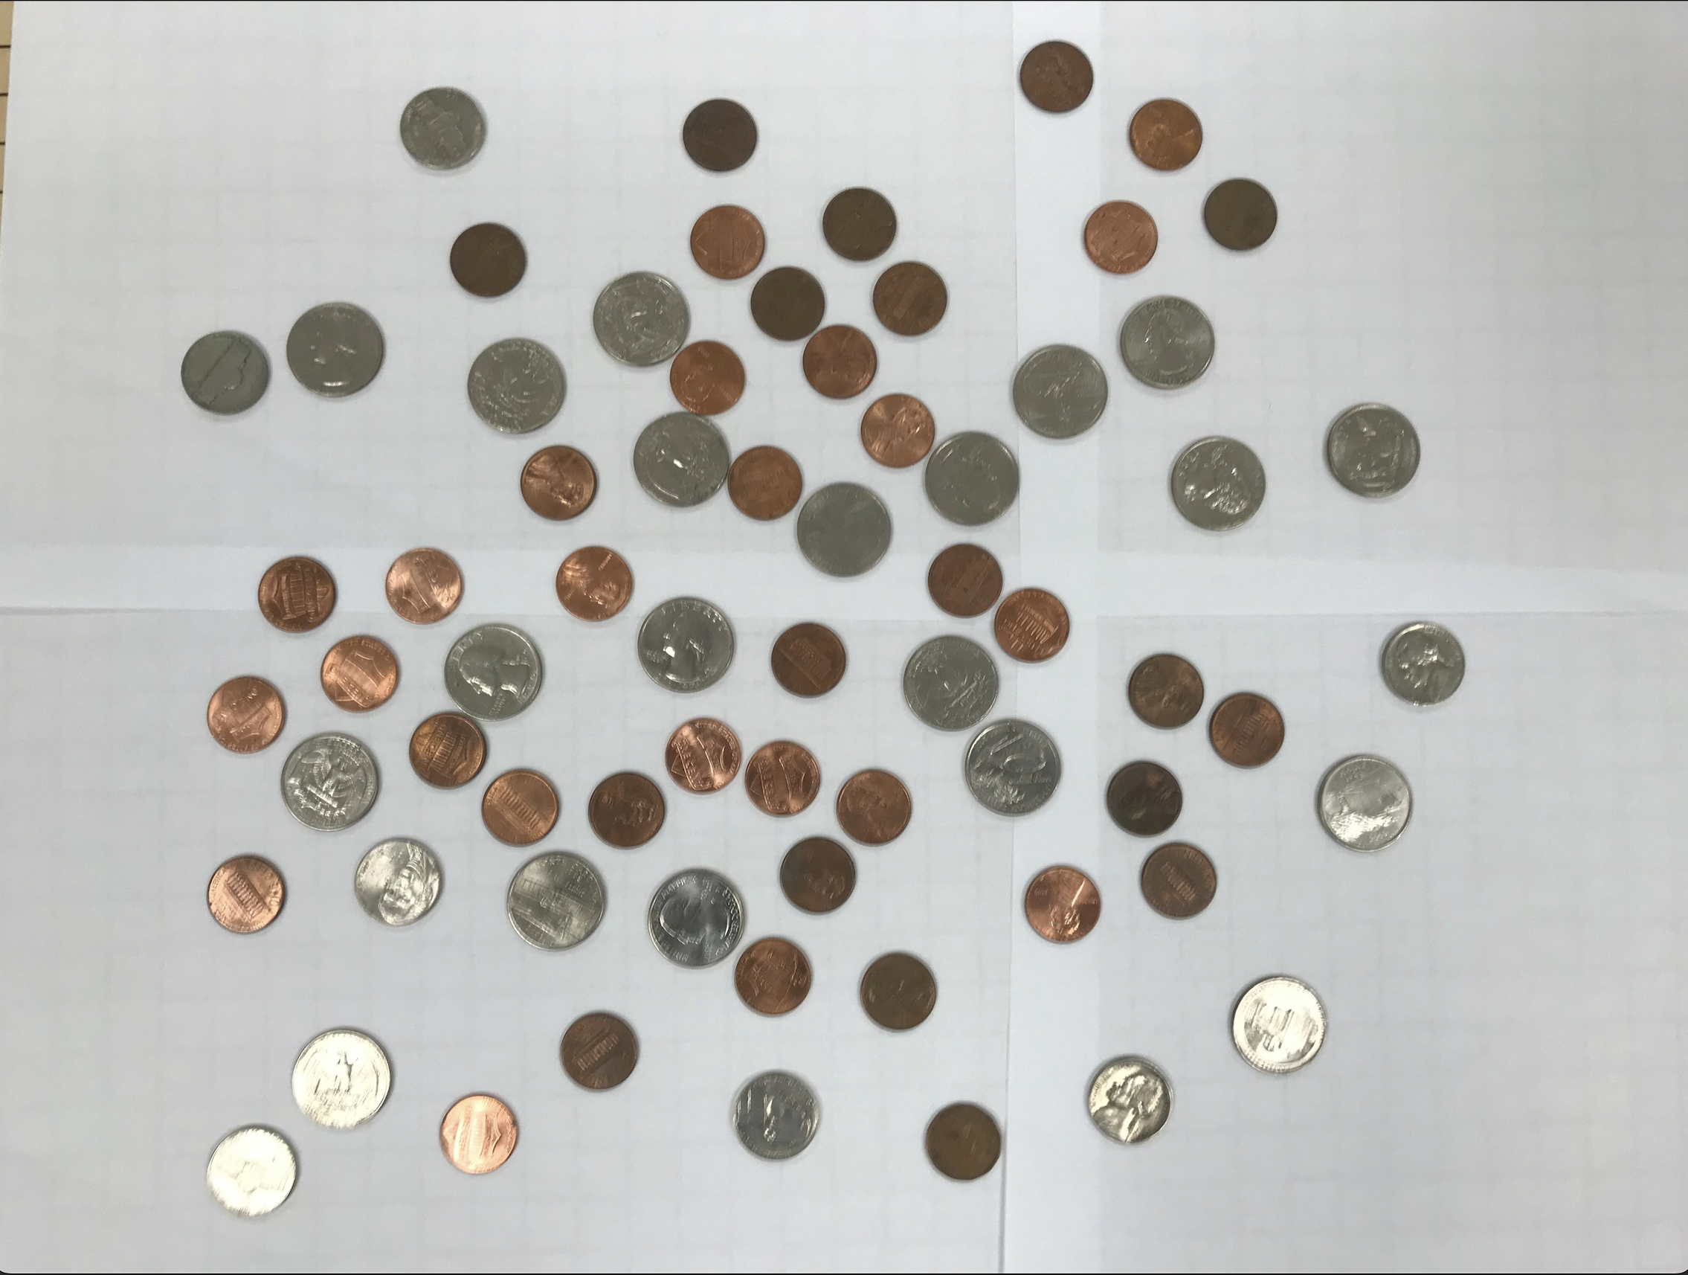

imagev.ppm:

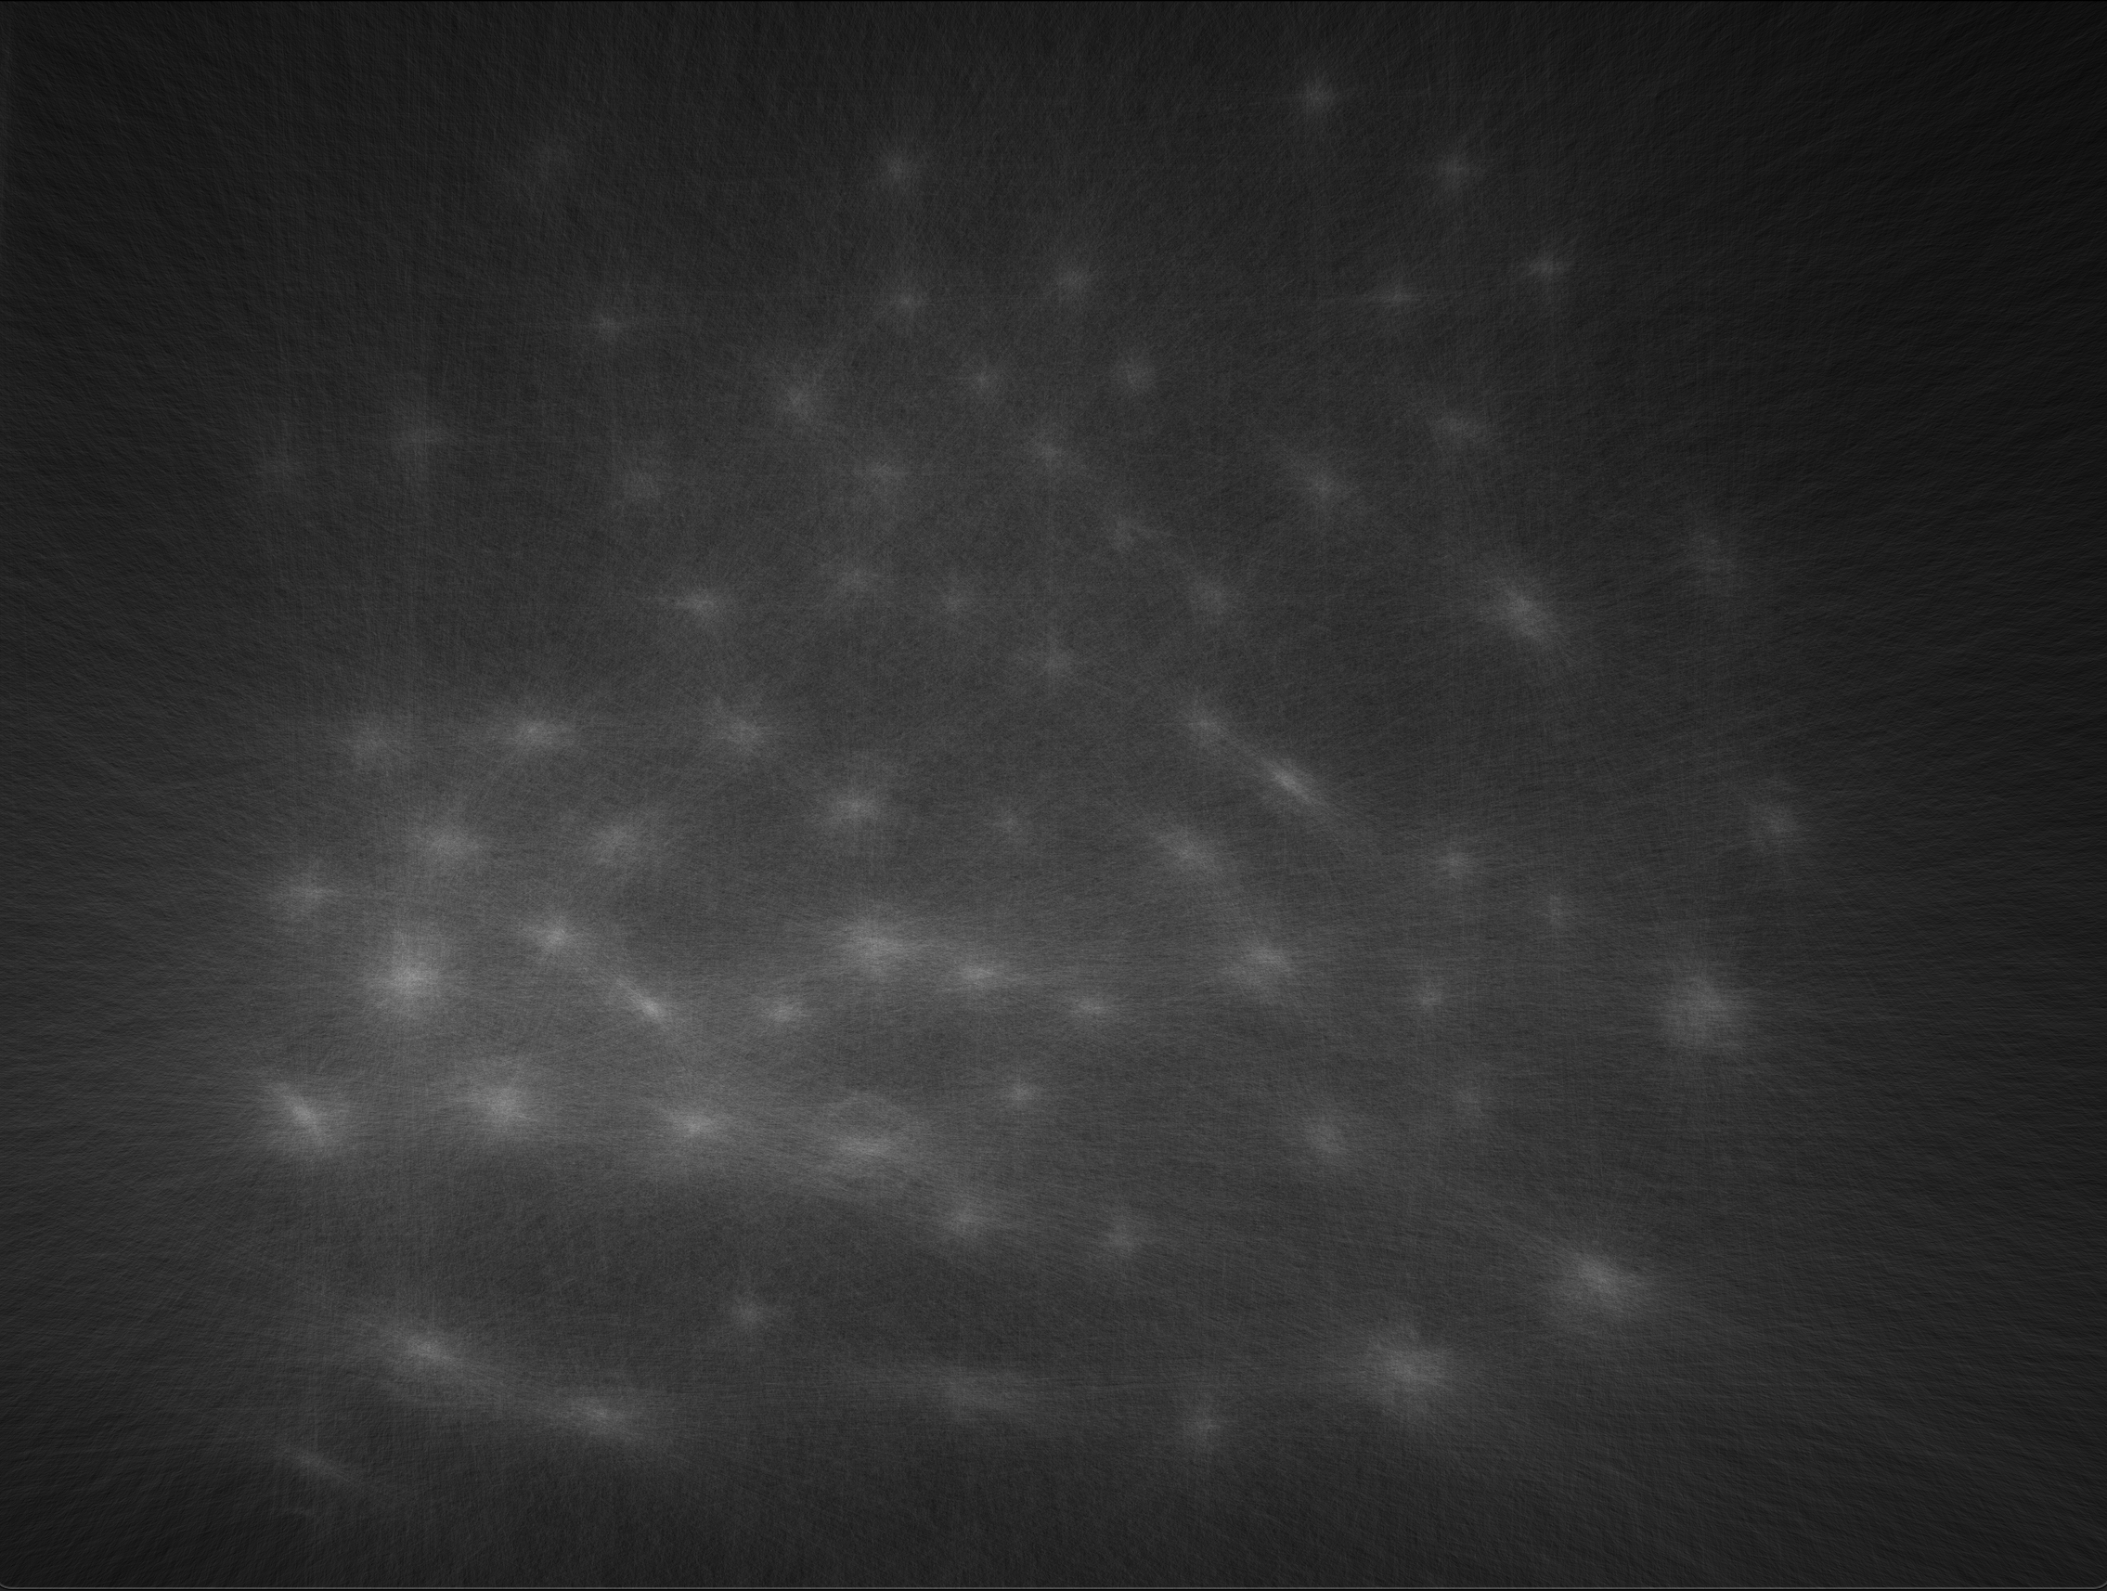

imageCoins.ppm:

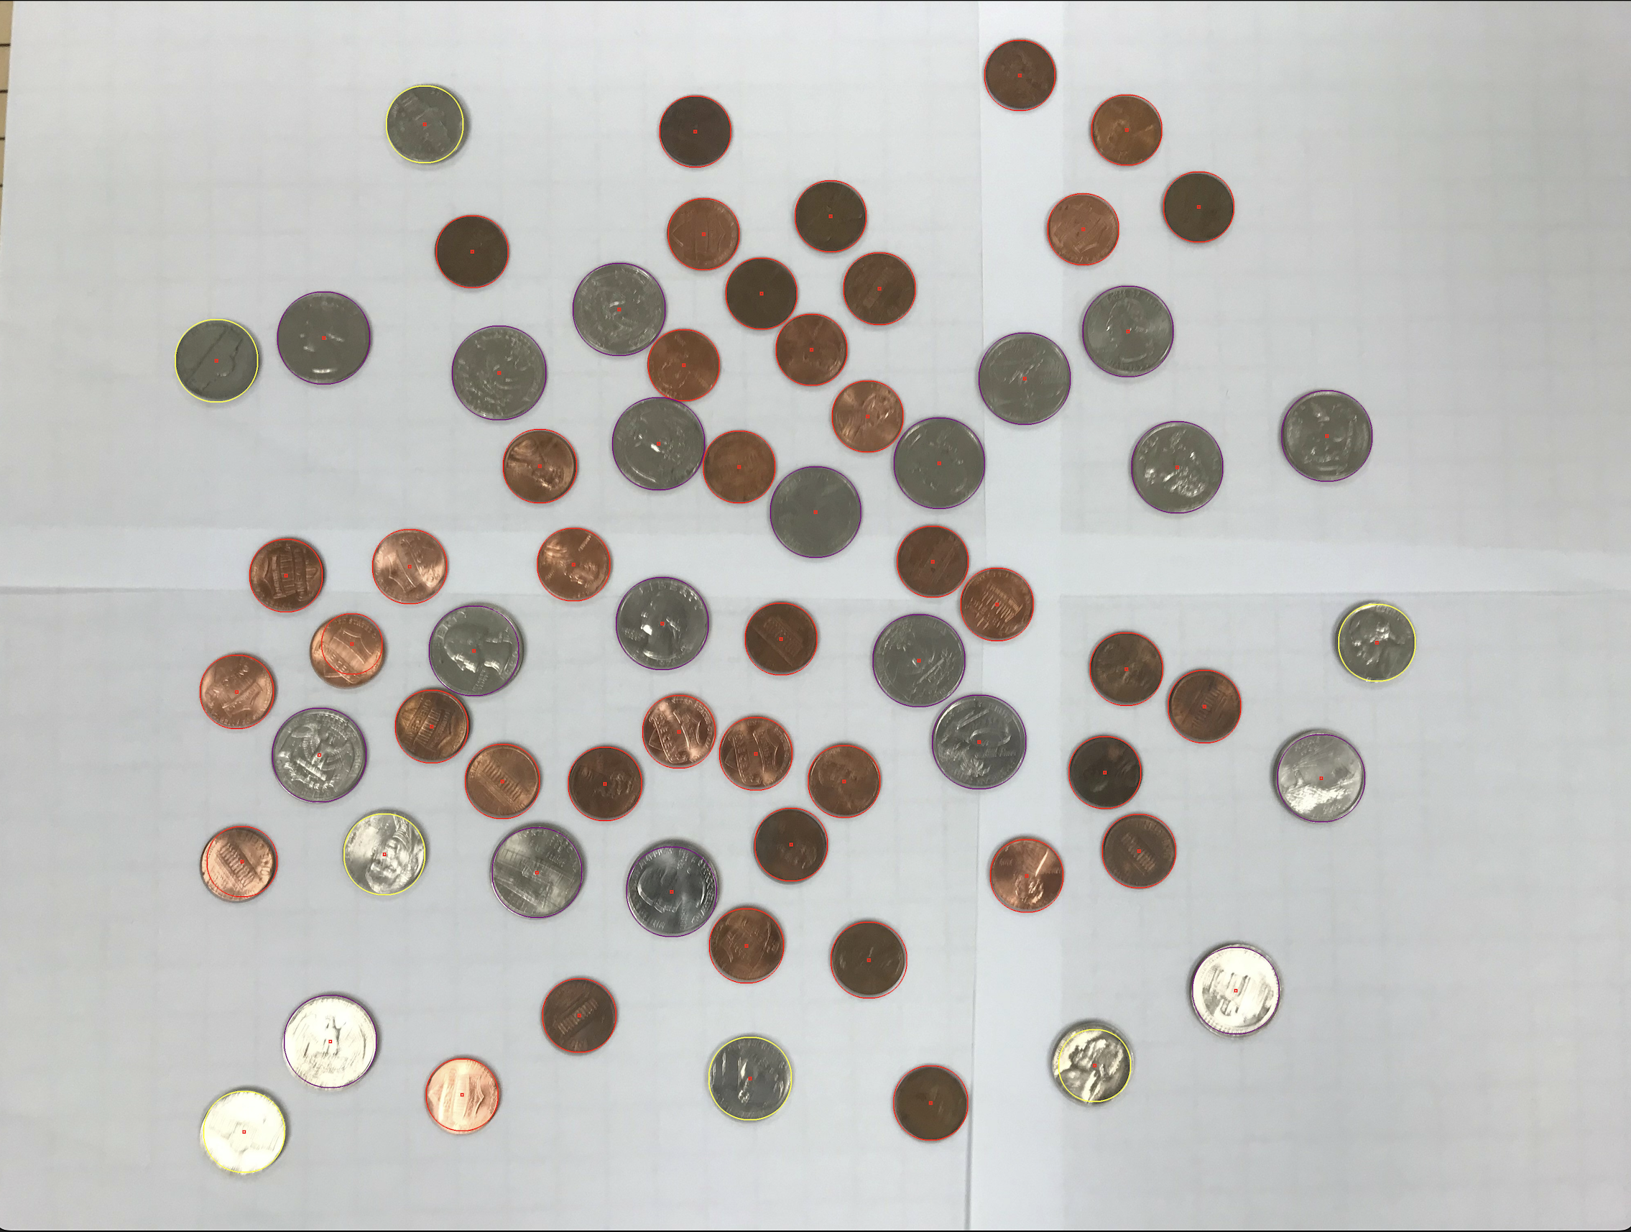

imageCircles.ppm:

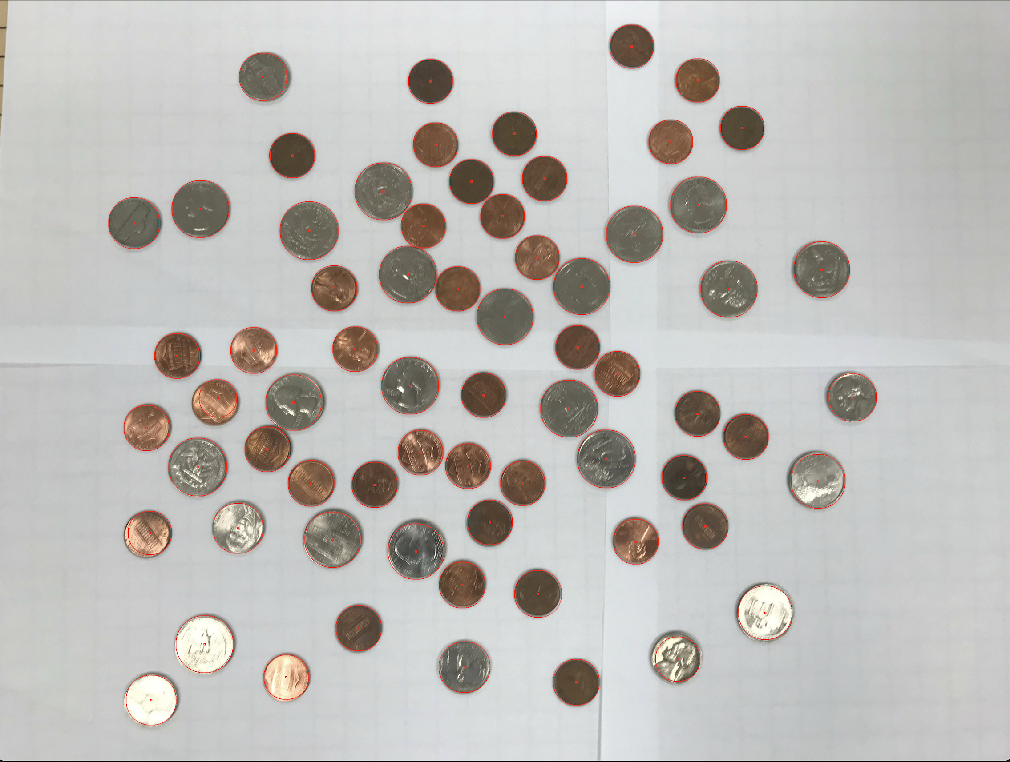

Content of results.txt: (NOT a printscreen so I can copy/paste if I need)

Half Dollar Coins: 0

Dollar Coins: 0

Quarters: 20

Dimes: 0

Nickels: 7

Pennies: 41

Total Sum: $5.76

Did you attempt to make your code work against the other 2 images? No

If yes paste here the same information as you did above for the easy image: